[A descriptive title]
ECSE 4660/6660 Internetworking of Things
[Date]
[team member1, abcde@rpi.edu, ECSE 4660]
[team member2, abcde@rpi.edu, ECSE 4660]

- Objective
This project will develop xx and demonstrate yy. xx will help people achieve goal zz.
Our idea/ demonstration will benefit society/students/institutes/world because… (Think of this as your next startup pitch). This should identify clearly the research question you're addressing.
- Innovation and Literature Review
This is an innovative idea and never demonstrated before in this form – some relevant projects found online are listed below… We are different from these works because…

- Methodology
A clear statement of your research methods. i.e., how are you going to solve the problems you've raised and motivated in the previous paragraph?
We will utilize xyz sensors and develop a protocol to communicate the date over abc.
The system diagram is shown in Figure 1. (One or more representative figures or block diagram to show your hardware/system flow.)

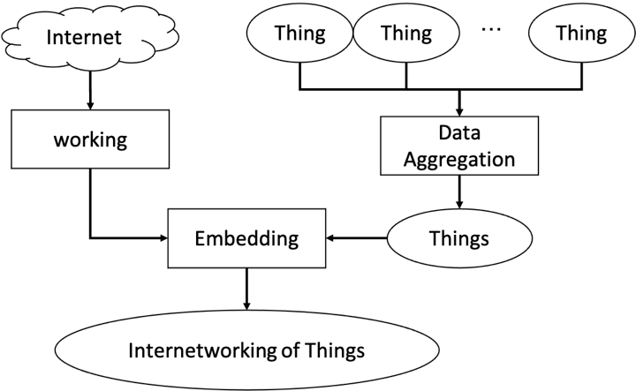
Figure 1 A schematic diagram of XX.
We first do a, then b. By collecting data and do c, we have d. Finally, e.
The protocol/algorithm/hardware/system/ we use is f.

- Hardware/Software Used
We will use compute platform, e.g., RPi’s, such-and-such sensors, PC running program V to visualize output, etc. The program will be written in Python/C/Java…, and the sensors will be from the IoT lab.
Make sure to check the list of sensors posted on Piazza. If the sensor is not listed and you don’t possess them yourself, we might be able to order from Amazon up to certain budget. Highlight the need to buy new sensors/hardware in your report.

- Demo and Deliverable
We will demonstrate the use and operation of XX in a live demo scenario. The algorithm/protocol will be shown by simulated/real application/or both. Students at 6000 level – describe your security component here.
- Plan and Timeline
A statement of plan and schedule, preferably in a table format, to convince us (and yourself!) that you can complete the project by the end of the term.
Actionable Item | Timeline
x | Mar 2 -16 (two weeks)
y

NOTE: We suggest that you team up within the same cohort (4660 or 6660). 6660 projects must include a security component.

If you have any questions, please post on Piazza or discuss with the instructor/TA.

